**chatbot-to-shop-for-essentials-during-pandemic-using-Watson-Assistant**

**Project report for smartbridge gurucool fdp**

**Created by**

**Souvik Biswas**

**Abstract**

Today whole world is in great danger due outbreak of covid 19 virus .It spreads through human contacts. So maintaining social distancing is one of the way to stop spread of this virus related disease. But we all have to buy some essential items to survive and for this we have to go outside of our home. During this we may be infected by the virus. This problem can be solved by online shopping portal. To make this online shopping experience easy and enjoyable here we create a chatbot which is capable of showing available items take order and customer details for delivering the product.

**Overview**

In this project I have created a shop chatbot to help user buy essential items.How a chatbot works? It waits for the user interaction. As user interact, it response to the user .Here I have created the chatbot using Watson assistant which helps to build conversational AI solutions and user interface is created it using node red services. My chatbot can display items, show offers, take orders and take personal details.

**Technology used**

* IBM Watson Assistant
* Node red services

**Design**

**Architecture of the application**

Chatbot created using Watson Assistant services

User interface created using node-red services

Here user interface is created using node-red services and chatbot is created using Ibm Watson services. User will interact with user interface which in turn interact with chatbot and display responses from chatbot.

**Scenario considered**

Chatbot is waiting for customer interaction .A customer begins to interact with the bot.He may start with greetings or directly go for product enquiry or begin to place order. If he buy something his personal details like name phone number delivery address are recorded. During order process customer can cancel orders.

User

Use case Diagram

Chatbot response

Welcome note

Greetings in response to greetings

Display different product category

Shows available vegetables

Shows available grocery items

Take orders

Shows available offers

yes

Block diagram of chatbot response

no

If customer want more items

Take personal details

**Implementation**

**Chatbot**

To implement the chatbot I have used three feature of Watson assistant and the features are intents, entities and dialog .Intents are used to grab probable user questions. Entities are used to identify keywords in user questions. Dialogs are used to generate chatbot responses.

User interface

For creating user interface node-red services are used. A form node is used for taking input. An assistant node is used to connect with Watson assistant. Function node s are used to format massages.A template node is used to show the response of the Chabot.

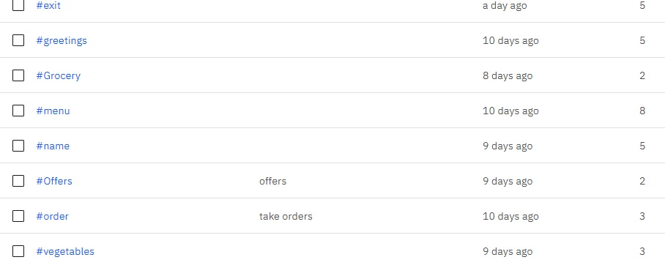

**List of intents**

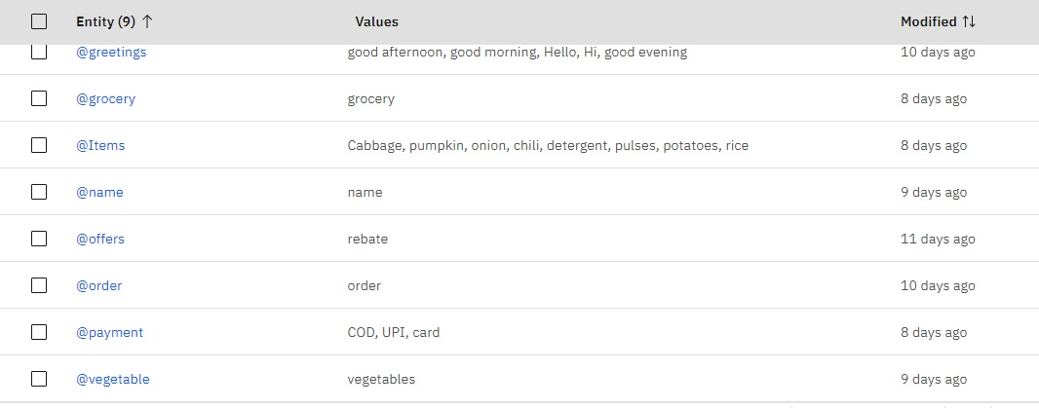

List of Entities

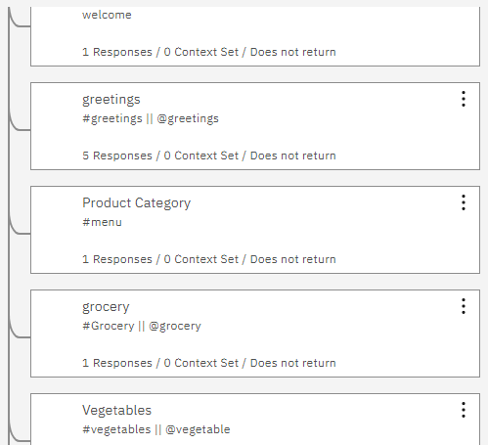

List of Dialog

Results

This application is working. It can perform following task

* Interact with the customer.
* Show available products, offers.
* Take orders.
* Cancel order.
* Gather personal information like name, address.
* Show the items user order.

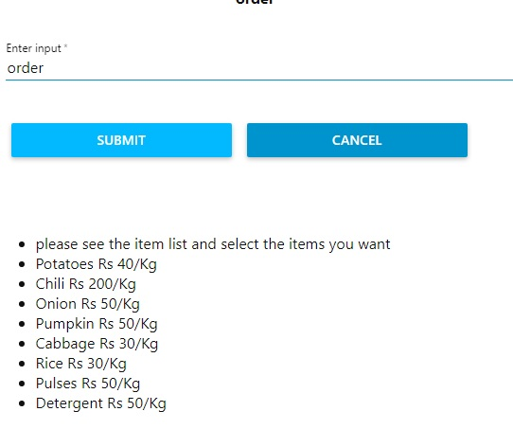

Response to order

**Limitation and Future scope**

This chatbot is static in the sense, here the items are fixed and prices are fixed. But in real life we should have provision for storing new items and update price time to time. It can not calculate total price In future this functionality should be incorporated.

**References**

1. [www.youtube.com](http://www.youtube.com)
2. [www.ibm.developer.com](http://www.ibm.developer.com)
3. www.smartinternz.com